**ICP3 Assignment**

**Name :** Barla Srujana

**ID :** 16322539

**Goal of Assignment :**

The main aspect of the assignment is to learn and understand bootstrap’s basics, foremost is Grid layout in bootstrap, the fundamentals of the Responsive Web Design (RWD) and basic java script.

The tasks in the ICPS are as follows:

**Task1:**

**1)Rock-Paper-Scissors:**

The task in this game is to design Rock-Paper-Scissors game. In this, user and the computer plays the game and scores are graded accordingly in the page. Computer and User selects their choice and, scores are given.

This task requires html, css and JavaScript. Below are the snapshots of the code:

**HTML Code :**

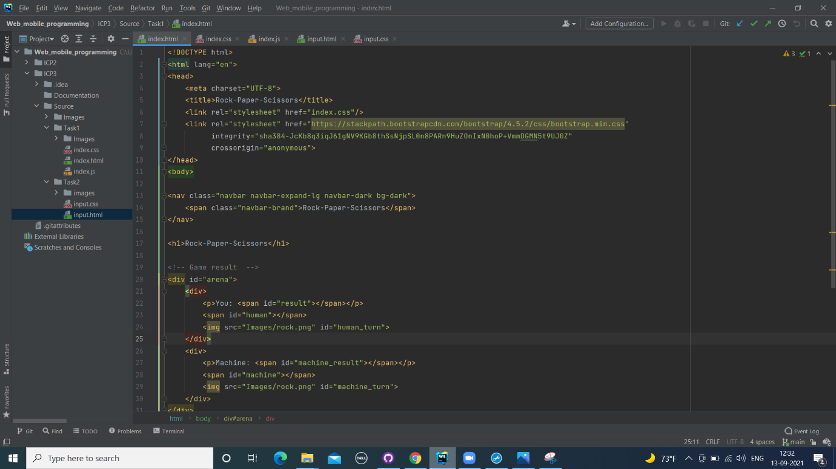

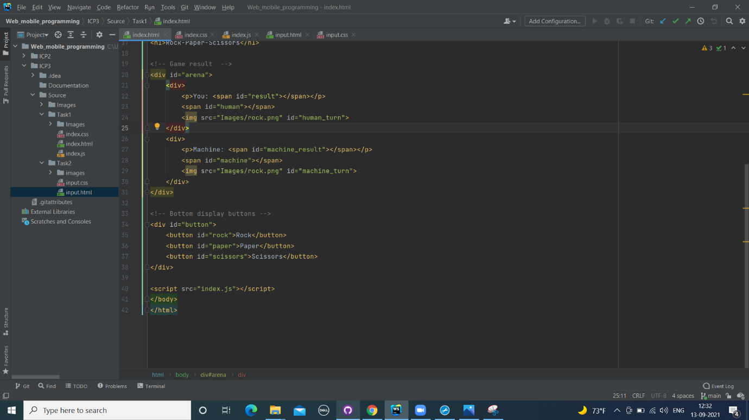

**CSS Code :**

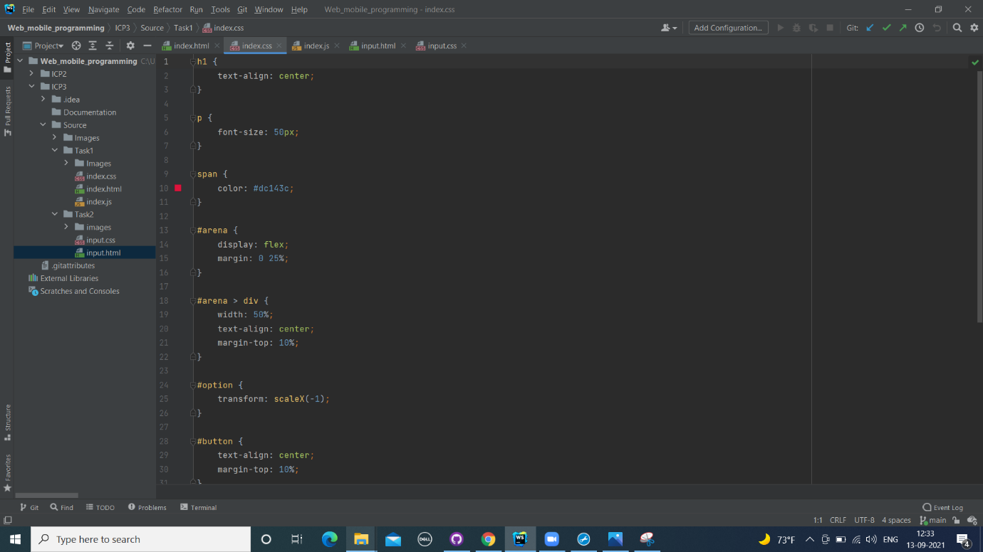

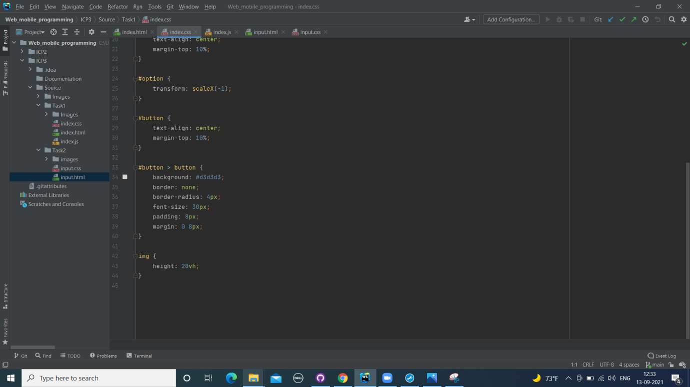

**JavaScipt** :

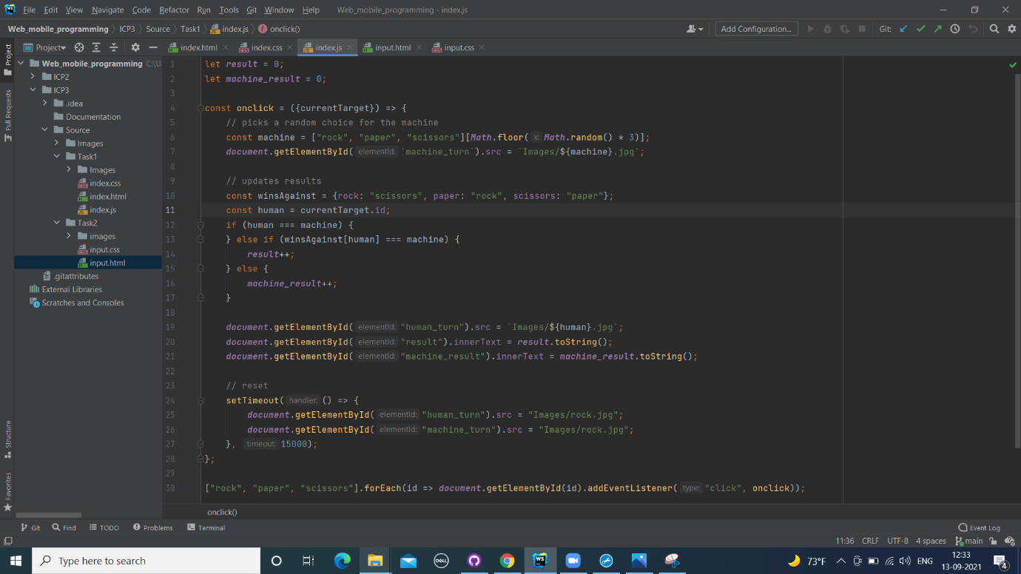

**Results of the Task1 :**

As soon as the web page is opened, below page is opened

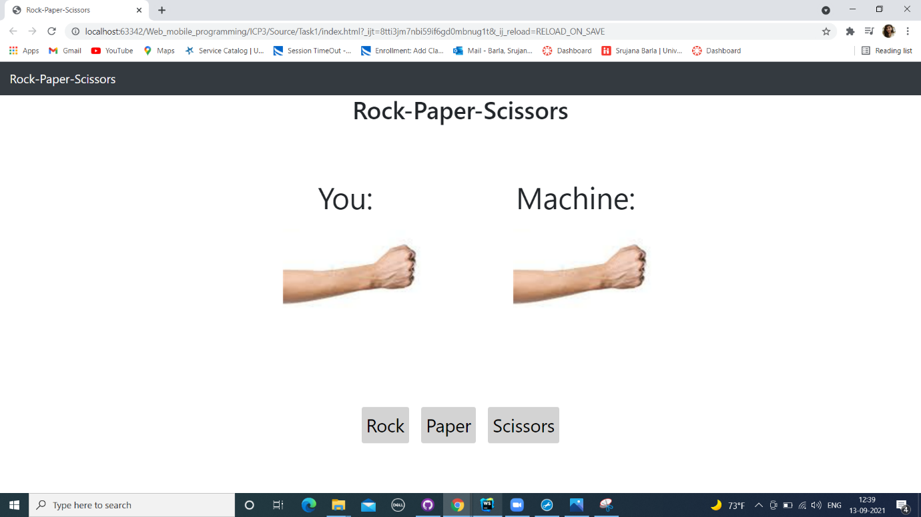

When game between Human and the System begins, the scoring is started. Below are the screenshots.

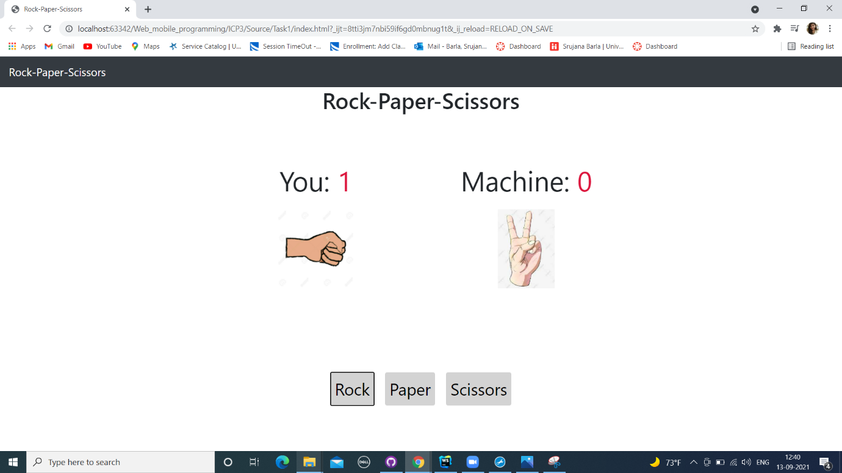

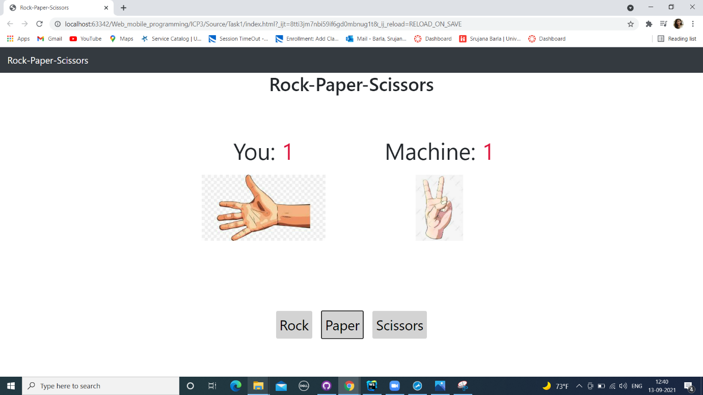

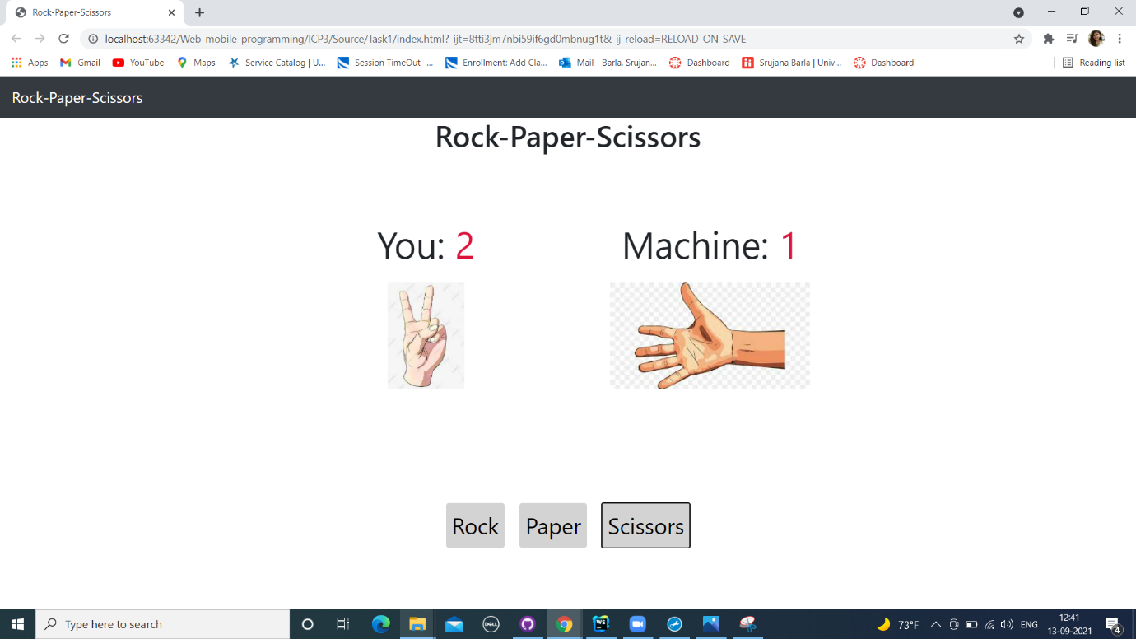

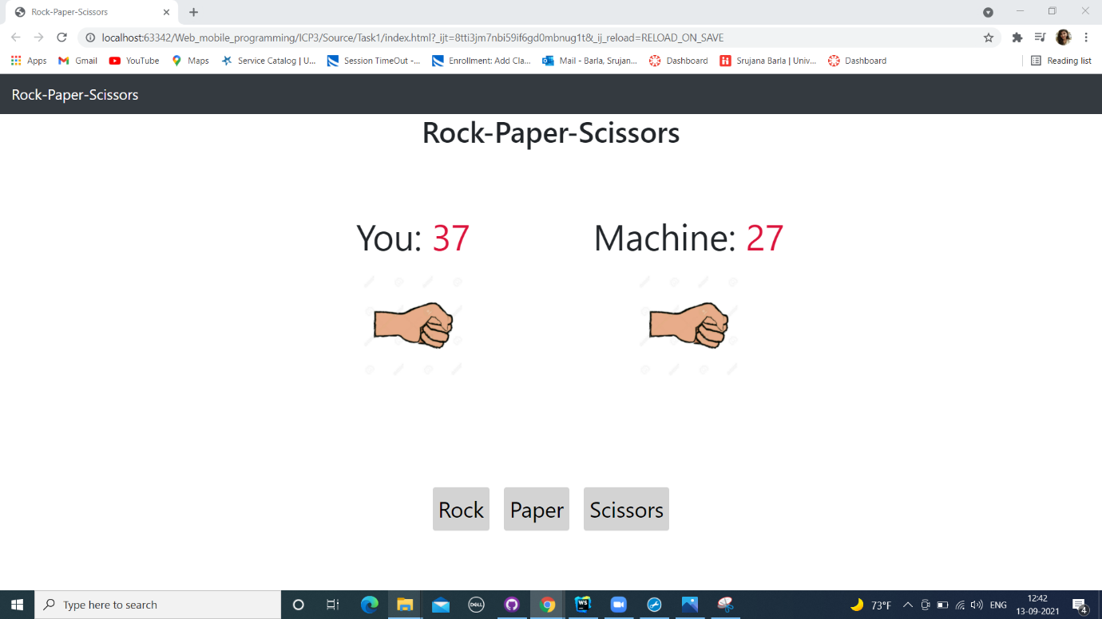

**Task2**:

**2)RWD Task:**

This RWD task is to design a mockup page.

In this we need to use Responsive Web Design. Firstly, all the images are resized and placed in the folders.

1)In this required Responsive Web Design Links are added. Then, name and designation is changed in the necessary fields. Images are also added in the code, which are resulted in the output page.

2)For background styling CSS is used.

Below are the snapshots of the RWD Task:

**HTML Code:**

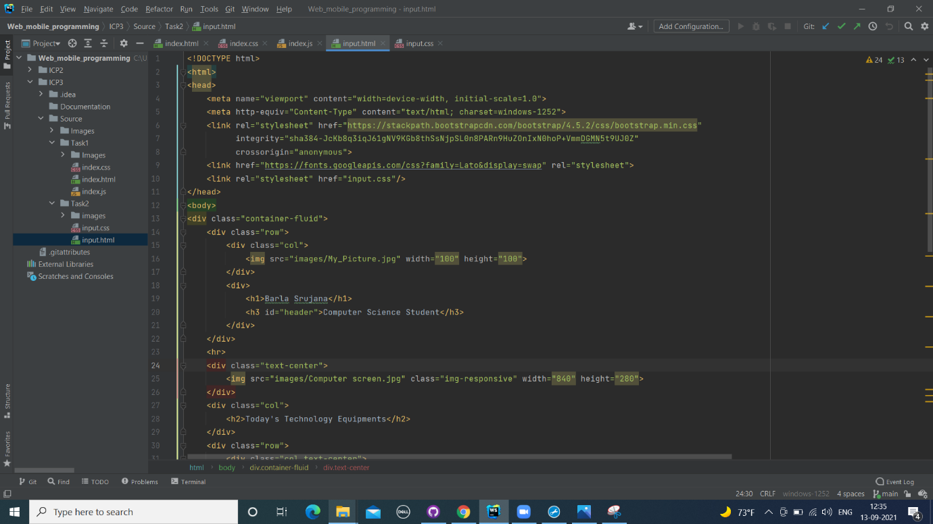

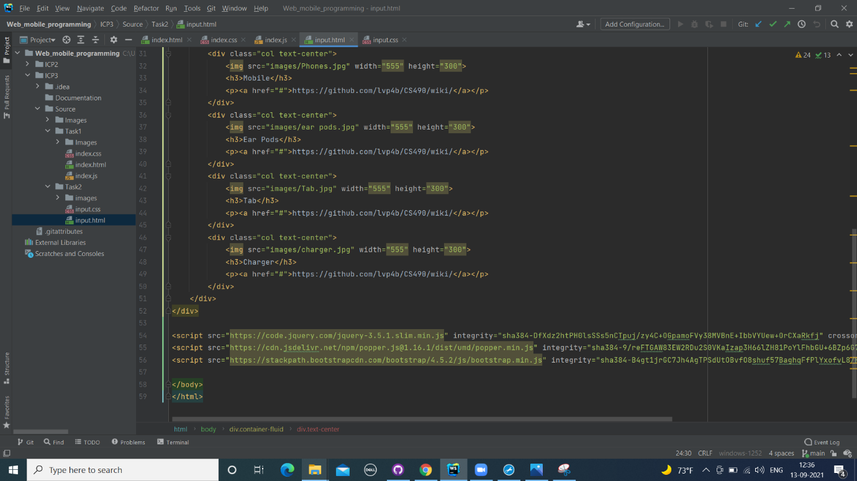

**CSS Code :**

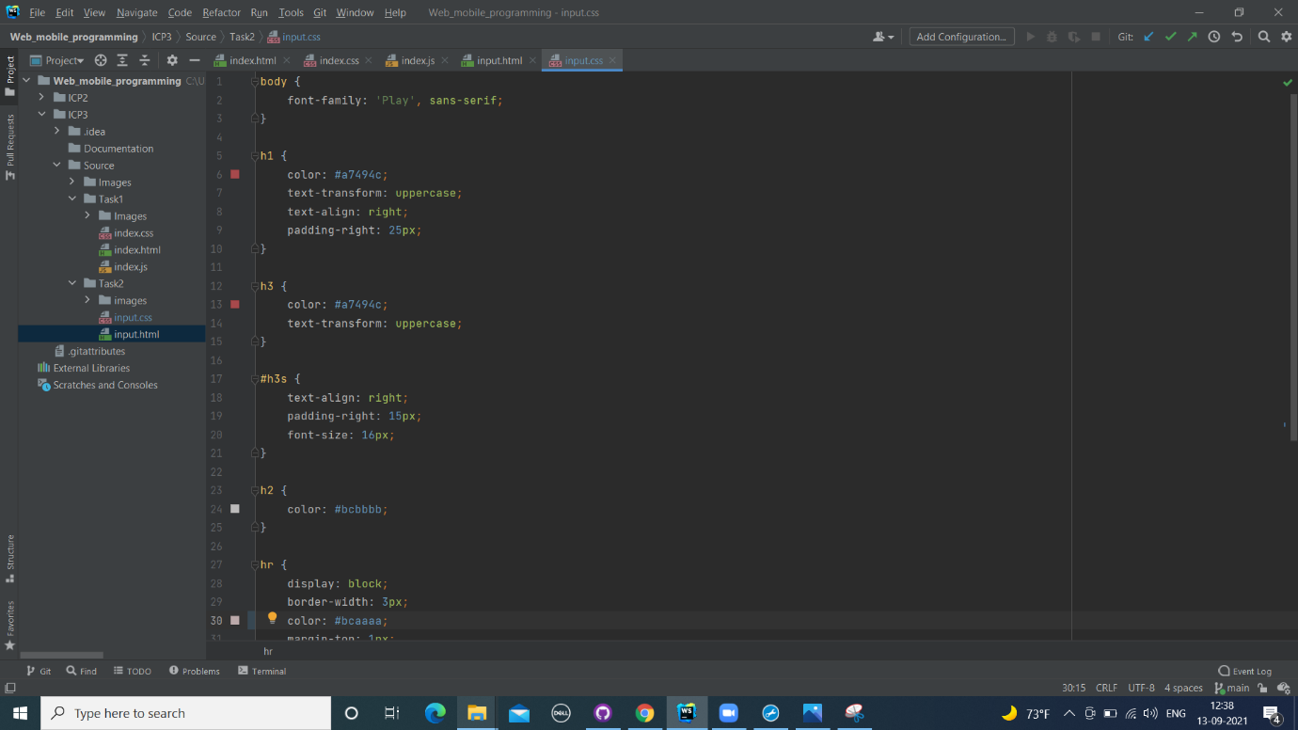

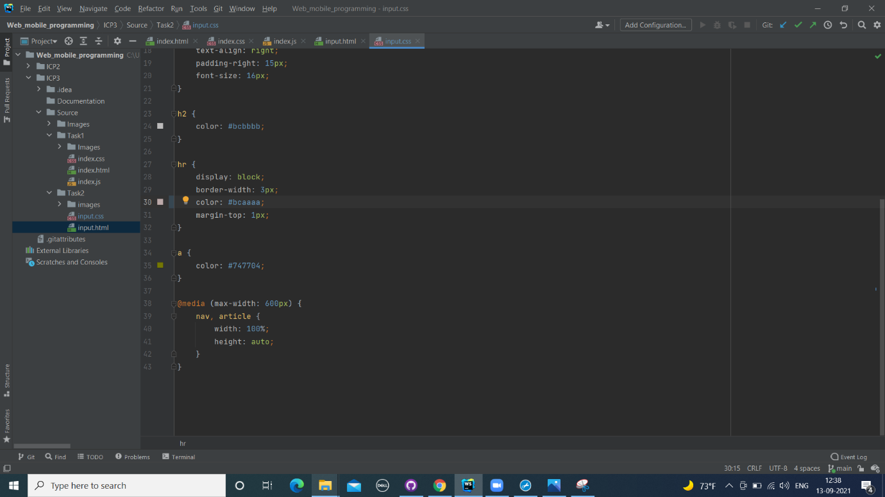

**Results:**

When the page is maximised page images are aligned. Then, when page is resized, images are aligned in the centre of the image as shown in the below.

